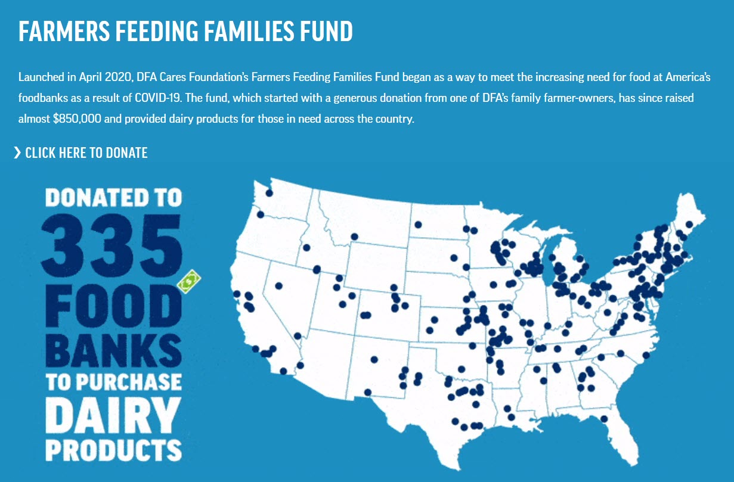

To learn more about DFA’s Farmers Feeding Families Fund,

Click here:

https://www.dfamilk.com/our-commitment/dfa-cares

